
Tribhuvan University
Faculty of Humanities and Social Science

LOAN APPLICATION SYSTEM

A PROJECT REPORT

Submitted to
Department of Computer Application
Danfe college

In partial fulfillment of the requirements for the Bachelors in Computer Application
Submitted by
Bibek Bhandari 92002104
Falgun 2082

Under the supervision of
Mr. ---------------------

Tribhuvan University
Faculty of Humanities and Social Science
Danfe College

Supervisor’s Recommendation

I hereby recommend that this project prepared under my supervision by BIBEK BHANDARI entitled "GREENLOAN Project (Loan Application System)" in partial fulfillment of the requirements for the degree of Bachelor of Computer Application is recommended for the final evaluation.

SIGNATURE
------------------
SUPERVISOR
Faculty Member
Department of Computer Application
Danfe College, Sinamangal Kathmandu

Tribhuvan University
Faculty of Humanities and Social Science
Danfe College

LETTER OF APPROVAL
This is to certify that this project prepared by BIBEK BHANDARI entitled “GREENLOAN Project (Loan Application System)” in partial fulfillment of the requirements for the degree of Bachelor in Computer Application has been evaluated. In our opinion it is satisfactory in the scope and quality as a project for the required degree.
SIGNATURE of Supervisor  -----------------  Department of BCA  Sinamangal, Kathmandu | SIGNATURE of Coordinator  Tul Bahadur Rai  Department of BCA  Sinamangal, Kathmandu
SIGNATURE of Internal Examiner  Internal Examiner | SIGNATURE of External Examiner  External Examiner

ABSTRACT

The GREENLOAN Project (Loan Application System) is a comprehensive software solution designed to streamline operations and enhance efficiency in financial sector. This application has the features of user-friendly environment and this project helps to manage the loan processing and application process. All the application status are tracked under this application. This application has also proposed for the program of afforestation. Each approved application helps to plantation of the trees. With the help of this application the officers and the users help to manage the loan application tracking and repayment is also made easy in this application.

Keywords: KYC, User, Loan Types, Approval, Alert, Verification, Documents

ACKNOWLEDGEMENT

Apart from the efforts, I would like to thank Mr. Deepak Thakur, our project coordinator and lecturer, for his patience, support and open-mindedness. Without his encouragement and guidance this project would not have materialized. I feel motivated and encouraged every time we attend his meeting. I take this opportunity to express our gratitude to the people who have been instrumental in the successful completion of this project. The guidance and support received from all the members who contributed and who are contributing to this project, was vital for the success of the project. I am grateful for their constant support and help.
Your sincerely,
Bibek Bhandari

Table of Contents
Chapter 1 Introduction 1
1.1 Introduction of Inventory Management System 1
1.2 Problem Statement 1
1.3 Objectives 2
1.4 Scope And limitation 2
1.4.1 Scope of the system 2
1.4.2 Limitations of the system 2
1.5 Report Organization 3
Chapter 2 Background Study & Literature Review 4
2.1 Background Study 4
2.2 Literature Review 5
Chapter 3 System Analysis and Design 6
3.1 System Analysis 6
3.1.1 Requirements Analysis: 6
3.1.2 Feasibility Study: 8
3.1.3 Data Modeling 1
3.1.4 Process Modeling 2
3.1.5 Algorithm Used 4
3.2 System Design 4
3.2.1 Architectural Design 4
3.2.2 Database Schema Design 6
3.2.3 Interface Design: 7
3.2.4 Physical DFD 10
Chapter 4 Implementation and Testing 11
4.1 Implementation 11
4.1.1 Tools Used (CASE tools, Programming languages, Database platforms) 11
4.2 Testing 13
4.2.1 Testing Cases for unit Testing 13
4.2.2 Testing Case for system Testing 16
Chapter 5 Conclusion and Future Recommendations 18
5.1 Lesson Learnt 18
5.2 Conclusion 18
5.3 Future Recommendations 18
References: 19
Appendices 20

List of Figures
Figure 1 Use Case Diagram 8
Figure 2 Gantt Chart 9
Figure 3 ER Diagram 2
Figure 4 Level 1 DFD 3
Figure 5 Level 2 DFD 3
Figure 6 Application Architectural Design 5
Figure 7 MVC Architectural Design 5
Figure 8 System Architectural Design 6
Figure 9 Database Design 7
Figure 10 Login page design 8
Figure 11 Purchase page design 8
Figure 12 Sale page design 9
Figure 13 Setup page design 9
Figure 14 Dashboard design 10
Figure 15 Physical DFD 10
Figure 16 System flow diagram 12
Figure 17 Login page 20
Figure 18 Change Password 20
Figure 19 Dashboard page 21
Figure 20 Sale page 21
Figure 21 Purchase page 22
Figure 22 Report page 22
Figure 23 Setup page 22

List of Tables
Table 2 Test case for login 13
Table 3 Test case for purchase 14
Table 4 Test case for sale 14
Table 5 Test case for supplier setup 15
Table 6 Test case for item setup 15
Table 7 Test case for system testing 16

List Of Abbreviations
DFD: Data Flow Diagram
ER: Entity Relationship
PHP: Hypertext Preprocessor
SQL: Structured Query Language
SIMS: Simple Inventory Management System
UC: Use Case
UI: User Interface
FRs: Functional Requirements
NFRs: Non- Functional Requirements
LIFO: Last In First Out
CASE tools: Computer Aided Software Engineering tools

Chapter 1 Introduction

1.1 Introduction of Inventory Management System
In today’s generation, we are engaged in highly computerized technology aiming to make individual lifestyles more comfortable and easier, especially in the world of business. The manual system is now considered the first process after the birth of the computerized system. Online transactions are now very common to widen the target market of the company. It becomes more efficient to the customer considering it can save time and is considered hassle-free. The most commonly used system by several companies is the sales system and inventory system creating a web-based system. Advanced system on sale provides more reliable recording of sales of the company with comparison to its actual cost. In addition to the data, information needed by the company to decide matters in relation to inventory can be easily generated. Moreover, the inventory control which ensures stocking the in-demand and correct items in the correct quantities. This sales and inventory system can help the company to avoid overstocking. When the company overstock, the fund will not back easy because the cycle of the stock is a stop for unneeded items requiring time, space, and funds which could have been used on more critical assets. The computer is a useful technology in our society that makes our work easy to wrap-up. Nowadays, computer technology continues to evolve and grow fast. Then every business in our society started shifting from using the manual system to an automated one that makes our work easier and faster. Point of Sales and Inventory System is a computer is an easy way of checking and listing the sales of the company, it is faster and more reliable rather than doing manually. The system can minimize human errors in editing and be easily accessed anytime by the company. Sales and inventory systems make the company more effective, more productive and are convenient for the company and its customers. The system is made to help the establishment show more relevant items to the customers.

1.2 Problem Statement
In the majority of small and medium businesses, efficient management of inventory still remains an uphill task. Manual processes of monitoring inventory are prone to errors, lack real-time status, and create inefficiencies in stock management. This leads to issues like incorrect inventory records, resulting in dispute in stock levels. Difficulty in tracking the movement of stock, resulting in stock outs or overstocking. Time-consuming manual processes, increasing workload and reducing productivity. Lack of transparency among owners and employees, thus resulting in mismanagement and losses.

1.3 Objectives
The main objective of this project is to develop an efficient and user-friendly Simple Inventory Management System that helps businesses manage their inventory effectively. The system aims to:
- Ensure accurate inventory tracking by providing real-time stock updates.
- Automate inventory management to reduce manual errors and improve efficiency and cost effective.
- Enhance transparency between business owners and staff through role-based access.
- Prevent stock-related issues such as overstocking and stockouts by generating alerts and reports.

1.4 Scope And limitation

1.4.1 Scope of the system
The Simple Inventory Management System is designed to aid small and medium businesses in efficiently managing and tracking their inventory. The system will:
- It saves time and effort for smooth records.
- Provide real-time stock updates to keep precise records of inventory.
- Automate stock entry, updates, and sales tracking to eliminate human-induced errors.
- Offer reports and analytics to facilitate decision-making.
- Allow role-based access to enhance openness between employees and owners.

1.4.2 Limitations of the system
While the system has several advantages, it also has certain limitations:
- The system is limited to inventory management and does not have full financial or accounting functionality.
- It requires internet connectivity for cloud-based functionality.
- Advanced features like AI-based demand forecasting are not included in the initial version.
- The system may not be suitable for very large companies with extremely complex inventory needs.

1.5 Report Organization
On completion of our project development, we have documented the milestones and the final document report has been organized under the following chapters. It shows the total overview and the organization flow of the report.
Chapter one “Introduction”
This chapter consists of overall view of the project i.e. the basic problem and its definition and general overview of the problem. It also specifies the software used and the proposed solution strategy.
Chapter two “Background Study and Literature review”:
This chapter determine of the basic fundamental’s theories, general concepts, and all the terminologies that are related to the project and the history of the SIMS and its market impact. Whereas in the literature review section we review similar projects done by others and what conclusions they find form the project. We collect the theory's paper and review their documents.
Chapter three “System Analysis and Design”:
This chapter describes the functional and non- functional requirements for the smooth running of the application. It describes whether the system that is designed is feasible or not. It also contains technical diagrams line the Data Flow Diagram and the Entity Relationship diagram.
Chapter four “Implementation and Testing”:
This chapter consists of implementation and testing with development methodology, tools used and testing process implemented throughout the development along with details about the system testing. This describes the different technologies used for the entire development process of the Front-end as well as the Back-end development of the application.
Chapter five “Conclusion and Future Recommendation”:
This presents projects with future enhancements possible for the project. This report also consists of screenshots of the projects with the working timeline in the project. This is the final chapter of the project. The projects the future are also mentioned in the chapter.

Chapter 2 Background Study & Literature Review

2.1 Background Study
Inventory management is a crucial component of business operations, ensuring that stock levels are efficiently monitored, maintained, and utilized. Traditional inventory tracking methods, such as manual record-keeping and spreadsheets, often lead to inefficiencies, errors, and data inconsistencies. These challenges have led to the adoption of computerized inventory management systems, which provide real-time tracking, automated stock updates, and detailed reporting.
Existing Inventory Management Systems
Several inventory management systems are available, ranging from Enterprise Resource Planning (ERP) solutions to small-scale inventory tracking software. These systems typically include:
- Stock Management: Keeping track of available stock, sales, and restocking requirements.
- Order Processing: Automating order placements and tracking purchases.
- Reporting & Analytics: Generating detailed reports for sales, stock levels, and business insights.
- User Access Control: Ensuring secure access for different roles (admin, staff, customers).
Challenges in Traditional Inventory Management
- Human Errors: Manual data entry increases the likelihood of mistakes.
- Time-Consuming Processes: Paper-based or spreadsheet tracking is inefficient.
- Stock Inaccuracies: Difficulty in maintaining real-time stock levels.
- Security Issues: Lack of proper authorization can lead to data manipulation.

Need for a Simple Inventory Management System
A Simple Inventory Management System aims to address these challenges by providing a user-friendly, automated platform that ensures transparency between business owners and staff. The system enhances efficiency by:
- Reducing manual workload through automation.
- Ensuring real-time stock updates to prevent overstocking or shortages.
- Providing role-based access control for secure data management.
- Generating reports for better decision-making and forecasting.
This project is designed to offer a cost-effective, scalable, and user-friendly inventory management solution tailored for small to medium-sized businesses.

2.2 Literature Review
For this project, we researched and compared various application and web based existing inventory management systems throughout in the internet, different organization has developed the inventory management system and we discovered that the most of the system are designed as the vast level through which the customer have to pay the recurring maintenance charge in every new feature or on the specific time.
Most of the organization is charging the most expensive price for the inventory analysis of the small organization which is unfair for the small organizations and institutions. Furthermore, manual tracking of all the items inside the institutions is most time consuming and needs lots and efforts and manpower. Most companies encounter:
- No live updates of stock, leading to overstocking or stockouts.
- Manual tracking of the goods is very challenging.
- Transparency and access issues, especially for the multi-user configurations.
- Generating the invoice and generating of copy of original invoices are hard to record.
- The user interface is very much complicated in other’s system

Chapter 3 System Analysis and Design

3.1 System Analysis
System analysis is the process of collecting and interpreting facts, identifying problems, and breaking down a system into its components. It helps in understanding the objectives of the system, improving its efficiency, and ensuring that all components work seamlessly to accomplish their purpose.

3.1.1 Requirements Analysis:
Requirement analysis for the Simple Inventory Management System involves identifying and defining the essential functionalities and constraints needed for efficient inventory tracking. It ensures that the system meets business needs by outlining functional requirements (such as stock management, order processing, and user roles) and non-functional requirements (including security, usability, and scalability). This process helps in structuring a clear, efficient, and user-friendly inventory management solution tailored for small to medium-sized businesses.
Functional Requirements:
- The admin can view, update, and manage inventory records.
- The admin can manage user accounts and assign appropriate access rights.
- The system can add, update, delete, and track inventory items.
- The system generates real-time stock reports and low-stock report.
- Users can view transaction history and generate invoices.

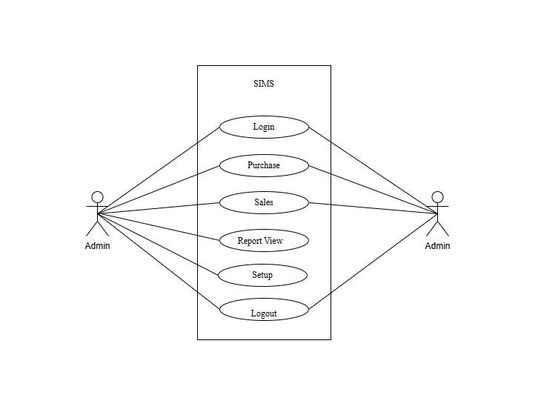
Figure 1 Use Case Diagram

Non-Functional Requirements:
Availability: The system will be accessible online for easy inventory tracking.
Security: User credentials and inventory records will be securely stored to ensure privacy.
Performance: The system will be optimized for fast response times and smooth navigation.
Reliability: The system will include data backup and recovery method to prevent data loss.

Gantt Chart (Project Timeline)
A Gantt Chart is used to visualize the project timeline and track progress. Below is a simplified breakdown of the project schedule:
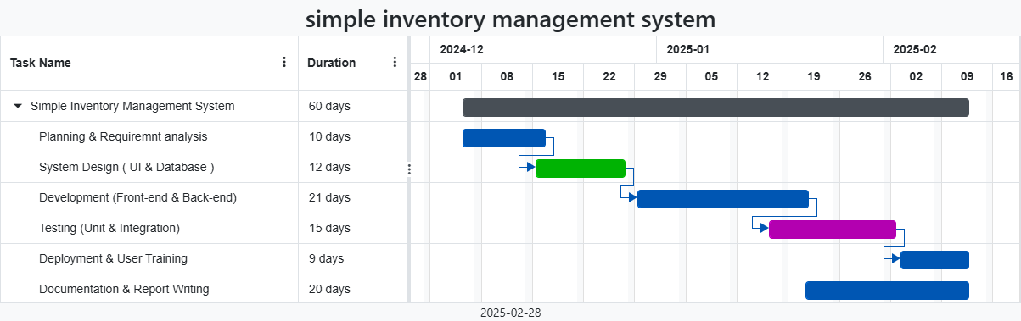
Figure 2 Gantt Chart

3.1.2 Feasibility Study:
A feasibility study evaluates whether the system can be developed with the required specifications within the given timeframe and resources.
Technical Feasibility
It is technically feasible, since there will not be much difficulty in getting required resources for the development and maintaining the system as well. The project is being built by using simple technologies to reduce technological hindrances. The project is written on VS Code (an open-source text editor. To deploy the application, the only technical aspects needed are mentioned below:
OS - Windows or any OS platform
RAM - 512MB or higher
Disk Space - 1GB or higher
Web Tools - HTML editors
Device - PC, Laptop, Android Device
Web Server – Xampp (for Apache server hosting and MySQL database)
Internet Browser – Any browser

Operational Feasibility
All the setup are managed by the admin in the initial stage of production environment. After the setup the staff can purchase the products and sale it. In this project, the admin will know the details of each project where he may be presented and the data will be maintained as decentralized and if any inquires for that particular contract can be known as per their requirements and necessaries.
Economic Feasibility
Development of this application is highly economically feasible. We didn’t spend much more money for its development. The only thing is to be done is making an environment for the development with an effective supervision. This application include the basic functions required for the small organization which helps in the records all the data digitally and requires less time consummation for the report analysis of the organization.

3.1.3 Data Modeling
A data model is a mechanism that provides abstraction for database application. Data models define how data is connected to each other and how they are processed and stored in a system. There are different data models which are used to design and develop the database, but here we use ER (Entity Relationship) Model. E-R Model is a popular high level conceptual data model that consists of a collection of basic objects called entities and relationship among these objects. The ER diagram of online furniture shopping system is as shown below:

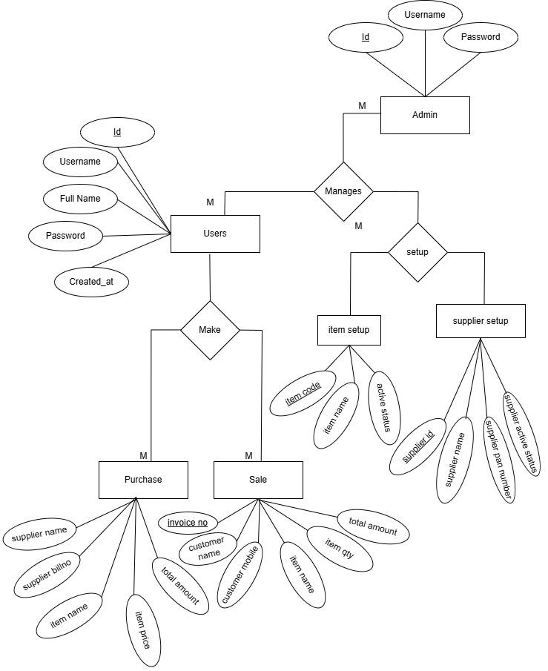
Figure 3 ER Diagram

3.1.4 Process Modeling
A DFD can be referred to as a Process Model. A data-flow diagram (DFD) is a graphical representation of the "flow" of data through an information system. A data flow diagram (DFD) is a significant modeling technique for analyzing and constructing information processes illustrates this flow of information in a process based on the inputs and outputs. Initially a context diagram is drawn, which is a simple representation of the entire system under investigation. This is followed by a level 1 diagram; which provides an overview of the major functional areas of the business. Level 2 business process diagrams give detailed analysis and then continue – through level 3, 4 and so on:
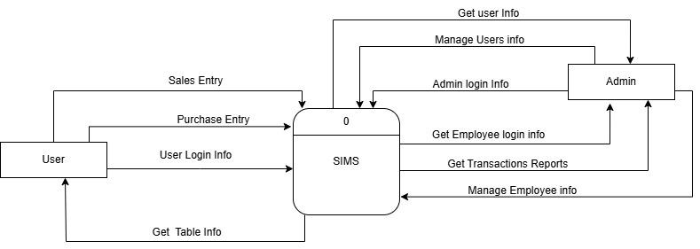
Figure 4 Level 1 DFD

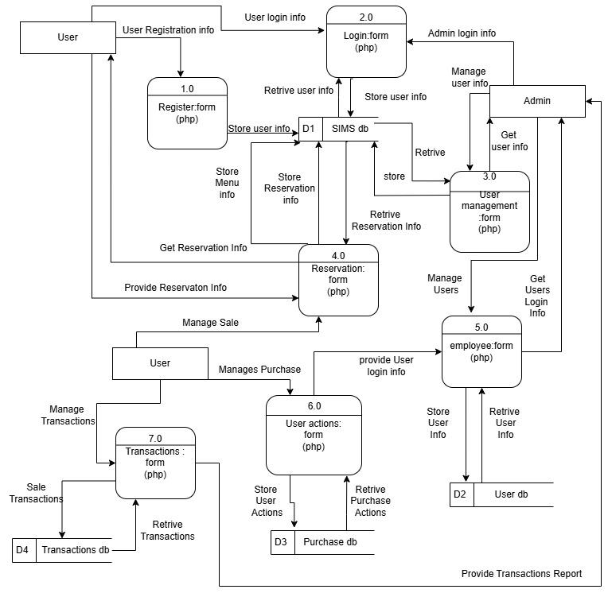
Figure 5 Level 2 DFD

3.1.5 Algorithm Used
There are different algorithms are used in the SMIS of the smooth operation of the project and makes the prefect result and output as the required for the daily operation of the inventory management.
Stock Management:
LIFO algorithm used for the management of the stock in the inventory. When the purchase is made the last purchased quantity of the item is sold out first and the so on.
Authentication and Authorization:
Password_hash() algorithm is used for the encryption and description of the user’s password. The PHP uses the random salt when using the password_hash() and used some functions of JavaScript and PHP.
Validation Management:
For the form validation, JavaScript is used in entire program and for the data validation and transaction management, PHP functions are used inside the program

3.2 System Design

3.2.1 Architectural Design
Architectural design is a process of identifying the sub-systems making up a system and the framework for sub-system control and commutation.

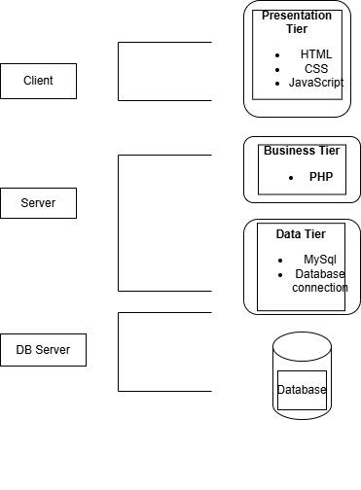
Figure 6 Application Architectural Design

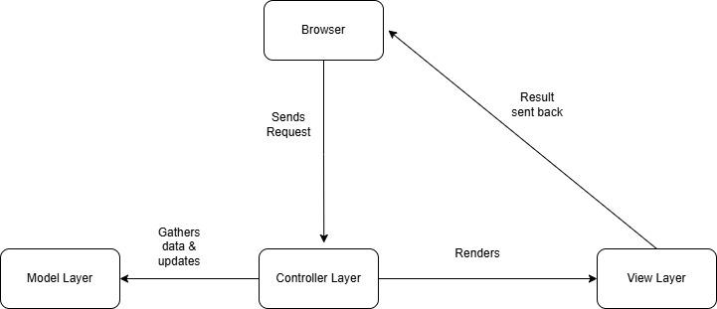
Figure 7 MVC Architectural Design
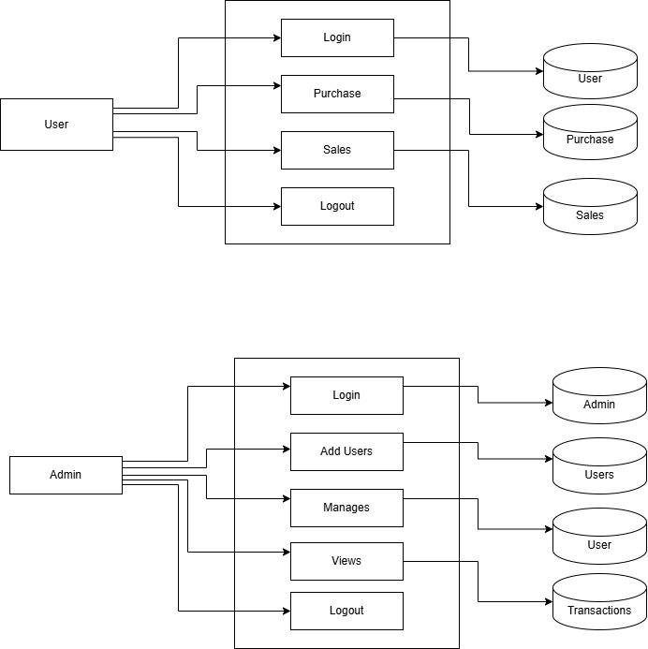
Figure 8 System Architectural Design

3.2.2 Database Schema Design
Database named admin Panel was created to do all the operations of the system by Administrator. The figure below elaborates the data table and its column along with the datatype used in the database and the relationship between the tables is also mentioned.

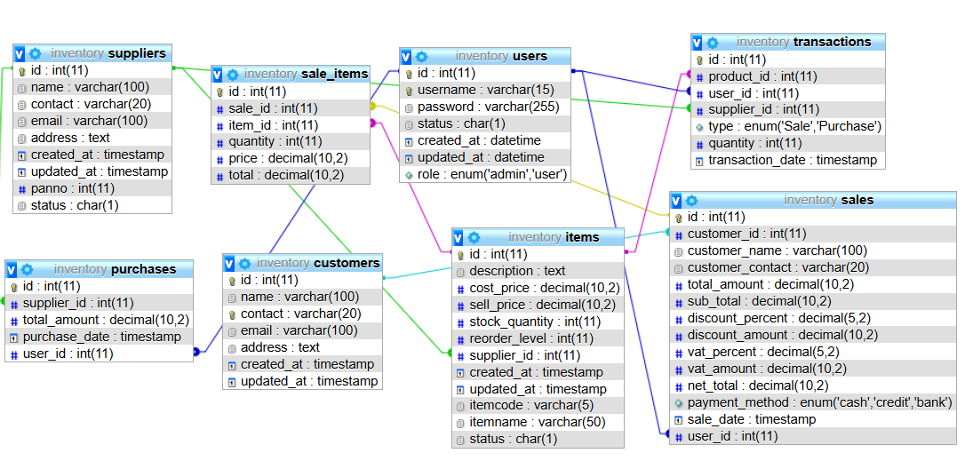
Figure 9 Database Design

3.2.3 Interface Design:
The interface design is used using the Figma focusing on the simplicity and usability and to understand the flow of UI/UX more comfortably. The primary interface includes the following interfaces:
Login page: Users can login their account in the login page.
Dashboard: Users can view overall monthly report management system
Sale: users can sell their product in the sale the inventory items
Purchase: users can make purchase for the inventory stock
Setup: Admin can manage their users, items, supplier in the setup
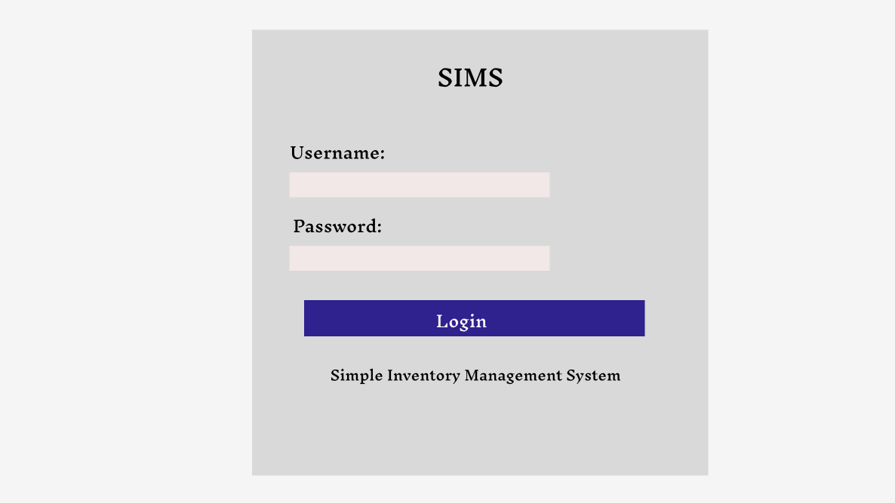
Figure 10 Login page design
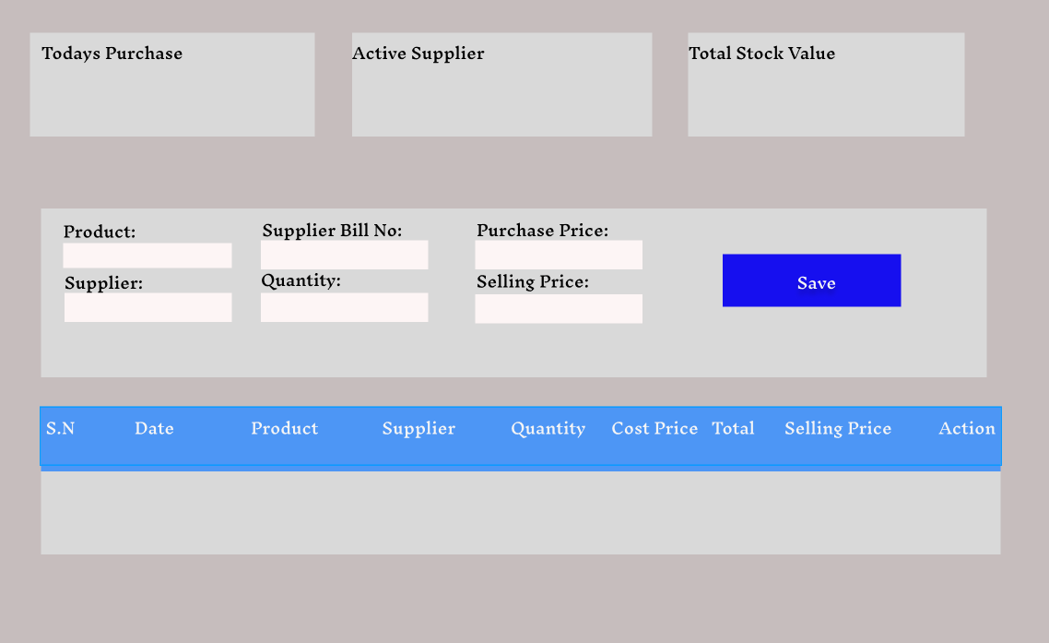
Figure 11 Purchase page design
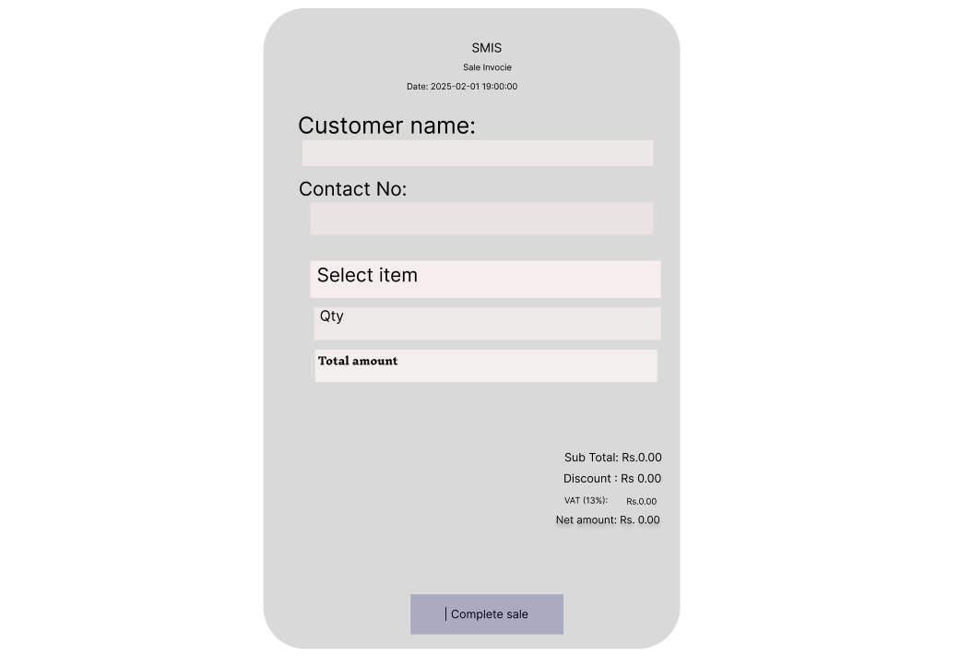
Figure 12 Sale page design
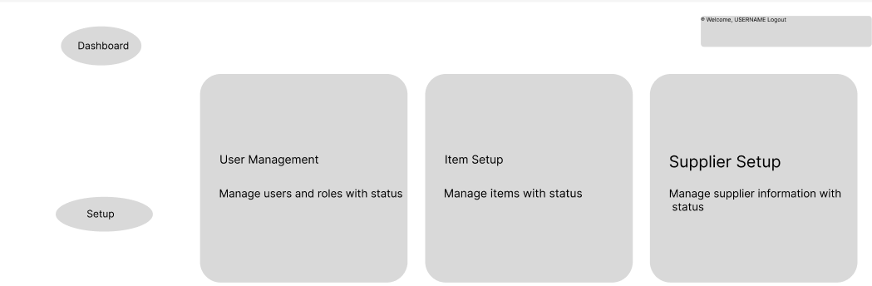
Figure 13 Setup page design
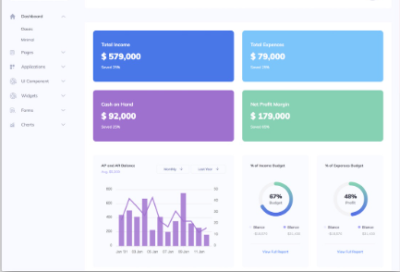
Figure 14 Dashboard design

3.2.4 Physical DFD
It explains the best method to implement the project however it involves the physical implementation of devices and files required for the project requirement. The below figure describes the structured design of the Simple Inventory Management System and working flow.
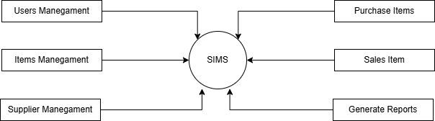
Figure 15 Physical DFD

Chapter 4 Implementation and Testing

4.1 Implementation
This chapter discusses how the inventory management system turned into practices focusing on the key features, functionalities and system work overview in SMIS. The different tools and testing cases along with the modules description and functionalities are described.

4.1.1 Tools Used (CASE tools, Programming languages, Database platforms)
Front-End Technologies:
HTML – HTML is used as the design of the view of the pages while help us in the development for the skeleton of the site.
CSS – CSS is used for the graphical UI of the pages. The skeleton is improvised using the CSS in the design. It is designed primarily to enable the separation of document content from document presentation, including aspects such as the layout, color and fonts.
JavaScript – JavaScript is used as the creation of the responsiveness of the site and for the increment in the user experience.
Bootstrap – For a mobile-friendly and responsive design of the site for the other devices pages.
Apache – Apache is used as the web server application that processes the requests and delivers the content to a browser or computer
Back-End Technologies:
PHP –PHP is used for server-side logic and handling database interactions. It handles the form and handles the database with logics in the project.
MySQL – MYSQL is used for storing inventory records, transactions, and user data as the database.
Development Tools:
VS Code – It is used as Code editing and development.
XAMPP – It is used for local server setup and database management.
GitHub – For version control and storing the code.
Implementing Details of Modules
The SIMS is divided into different module for the basic needed of the project. The different module used in this program is defined below along with the figure

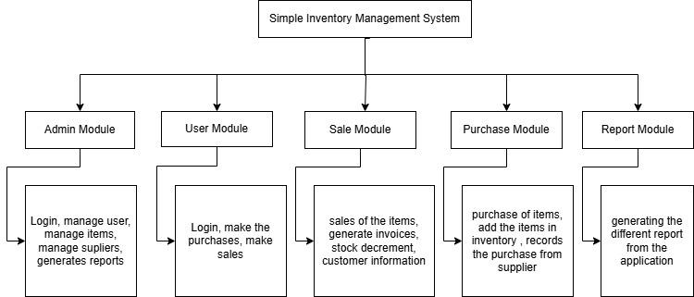
Figure 16 System flow diagram
Admin Module: This is the module designed for the dedicated use of the administration purpose. All the features and the function throughout the project is accessible to the admin role user.
User Module: The limited permission is given to the user for the control of the permission throughout the project. The permission is needed as the more function is required for the user.
Sale Module: In this module, both the user and admin can sell the product that are at the stock in the inventory. In this module the both users can record the sale, customer info and generates the invoices.
Purchase Module: In this module, both the user and admin can make the purchases and entry the bill. The saved bill is recorded as the items are added in the inventory.
Report Module: In this module, the admin can view the report and analysis the data of the sales and purchase along with the user collection

4.2 Testing
This is the phase for finalizing the product and rectifying the bugs and errors throughout the program. The testing is the essential part of the project for uncovering the features and function of the project.

4.2.1 Testing Cases for unit Testing

Table 1 Test case for login
Pre conditions: user is already registered in system
SN | Expected result | Expected result | Actual result | Remarks
1 | Navigate to login page | Login page should open | User is navigated to lo page | User was able to navigate the login page of SIMS
2 | Provide valid username and password | User must login successfully | User logged into the system | User was able to redirect to dashboard
3 | Incorrect username and correct password | User must not login | User was not able to logged in to the system | User was not able to make login
4 | correct username but incorrect password | User must not login | User was not able to logged in to the system | User was not able to make reservations
Post condition: user is validated with database and successfully login to SIMS

Table 2 Test case for purchase
Pre conditions: user has all necessary information
SN | Expected result | Expected result | Actual result | Remarks
1 | Navigate to purchase page | Purchase form should open | User is navigated to purchase page | User navigated to purchase page of SIMS
2 | Provide all required information | Purchase should save successfully | Purchased should saved | User was able Purchase items
3 | Any of the information not provided | User must not fill required fields | Alert for missing info necessary | Alert shown in the danger color
Post condition: Purchase should be saved successfully

Table 3 Test case for sale
Pre conditions: user has all necessary information
SN | Expected result | Expected result | Actual result | Remarks
1 | Navigate to Sale page | Sale form should be opened | User is navigated to sale page | User was able to navigate the sale page of SMIS
2 | Provide all required information | User must fill up all information | All data calculated and showed result | User was able to add items list
3 | Any of the information not provided | User must not give to save bill | User was not to save the sale | User was not able to save the bill
Post condition: user can save the bills and generate invoice

Table 4 Test case for supplier setup
Pre conditions: user has admin role in permission
SN | Expected result | Expected result | Actual result | Remarks
1 | Navigate to supplier setup page | supplier setup page should open | supplier setup page opened | User was able to navigated to supplier setup of SIMS
2 | Add supplier | supplier added successfully | supplier saved successfully | Supplier was added into the system
3 | Edit supplier info | Suppliers’ info modifies | supplier info modified | Supplier information update in database.
4 | Any of information is not provided | Supplier detail is required | Supplier was not saved | Supplier was not saved into database
Post condition: user is registered into the database and can login into the system
Table 5 Test case for item setup
Pre conditions: user has admin role in permission
SN | Expected result | Expected result | Actual result | Remarks
1 | Navigate to item setup page | item setup page should open | item setup page opened | User was able to navigated to items setup of SIMS
2 | Add items | Item added successfully | Item saved successfully | Item was added into the system
3 | Edit users’ info | Items info modifies | item info modified | Items’ information update in database.
4 | Any of the information not provided | Item detail is required | Item was not saved and error raised | Item was not saved into database
Post condition: user added in database and can logged in successfully

4.2.2 Testing Case for system Testing
Table 6 Test case for system testing
ID | Test Case Description | Test Data | Expected Result | Actual Result | Test Result
ST-001 | Test for the login of the user | Valid User login detail | User should login and redirected to dashboard | User login succeeded and page redirect to dashboard | Pass
ST-002 | Test for the side menu bar | Validated responsive page | Every menu linked with pages | Every menu liked with page | Pass
ST-003 | Test for the item Setup | Valid data input | Item setup page open and save the information | Item page opened and info saved in database | Pass
ST-004 | Test for the supplier setup | Valid data input | Supplier setup page open and save information | Supplier page opened and save in database | Pass
ST-004 | Test for the users | Valid data unput | Users’ setup page open and save information | User page opened and save in database | Pass
ST-005 | Test for the purchase | Valid data input | Purchase page should open and save information | Purchase page opened and saved in database | Pass
ST-006 | Test for the sale | Valid data input | Sale page should open and save information | Sale page opened and save in database | Pass
ST-007 | Test for the reprint of sale bill | Reprint previous bill | Reprint the previous bill with reprint tag | Reprinted bill with reprint tag | Pass
ST-007 | Test for alter database | setup database | Database alter successfully | Database altered success message | Pass
ST-008 | Testing for every menu | Valid user input | Click over every menu and option | Everything is working well | Pass

Chapter 5 Conclusion and Future Recommendations

5.1 Lesson Learnt
The development of the SMIS system was challenging and made a lot of effort for me. The syllabus of fourth semester was very helpful during the completion of the project. In this project the main outcome of the project was a quick records entry and the evaluation of the reports and the transactions. This system was very easy to user and very user-friendly during the testing stage. The UI of the system and quick responsiveness and attractive design along with the color combination made the project worth meaning full. This project help in the quickly analysis of the financial report, and inventory stock count report for the current status of the item.

5.2 Conclusion
In summary, SMIS emerged as a user-friendly web application aimed at revolutionizing the scrap collection process. By addressing the inefficiencies and limitations of traditional methods, it provided a robust solution that connected individual buyers directly with sellers. The project documentation highlighted the development process, including the technical challenges and solutions implemented. Scrap-Z not only facilitated better communication and transaction efficiency but also contributed to environmental sustainability by promoting the responsible disposal of scrap materials. The success of Scrap-Z underscored the importance of integrating digital innovations in traditional sectors for improved outcomes.

5.3 Future Recommendations
Sale return: To increase the user environment more flexible and convenient to use the sold can also be returned if the customer claims any money back.
Reports: In the future any report format and the data can be extracted from the software.
Payment Integration: The direct payment system from bank that are made by card or QR or any other digital payment method can be integrated directly into the system
Notification: The direct notification to email for the low stock items can be easily implemented into the system
User registration: New user registration by new employee and be directly implemented into the system in future.

References:
PHP.net, “PHP manual and tutorial”, https://www.php.net
GeeksforGeeks, “Web Development tutorial”, https://www.geeksforgeeks.org
W3school, “HTML, CSS and JavaScript tutorial”, https://www.w3schools.com
Windsurf, “problems and debugging challenges”, https://codeium.com/windsurf
JavaTPoint, “java script tutorial and scripts”, https://www.tpointtech.com
Gantt Chart, “tracking the task duration for”, https://www.onlinegantt.com

Appendices
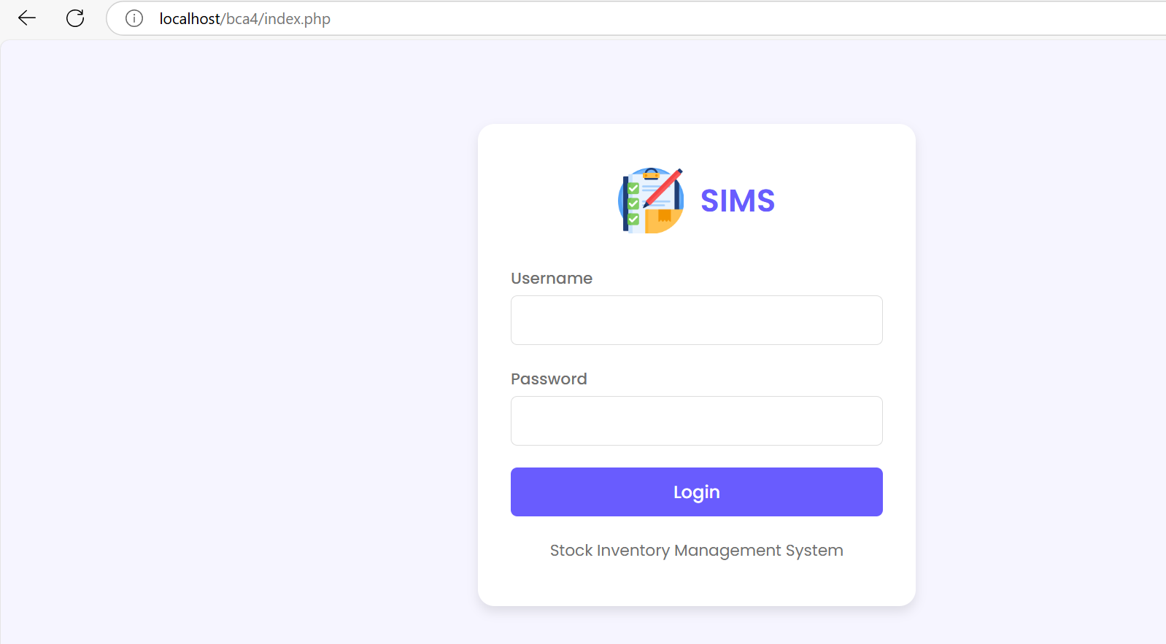
Figure 17 Login page
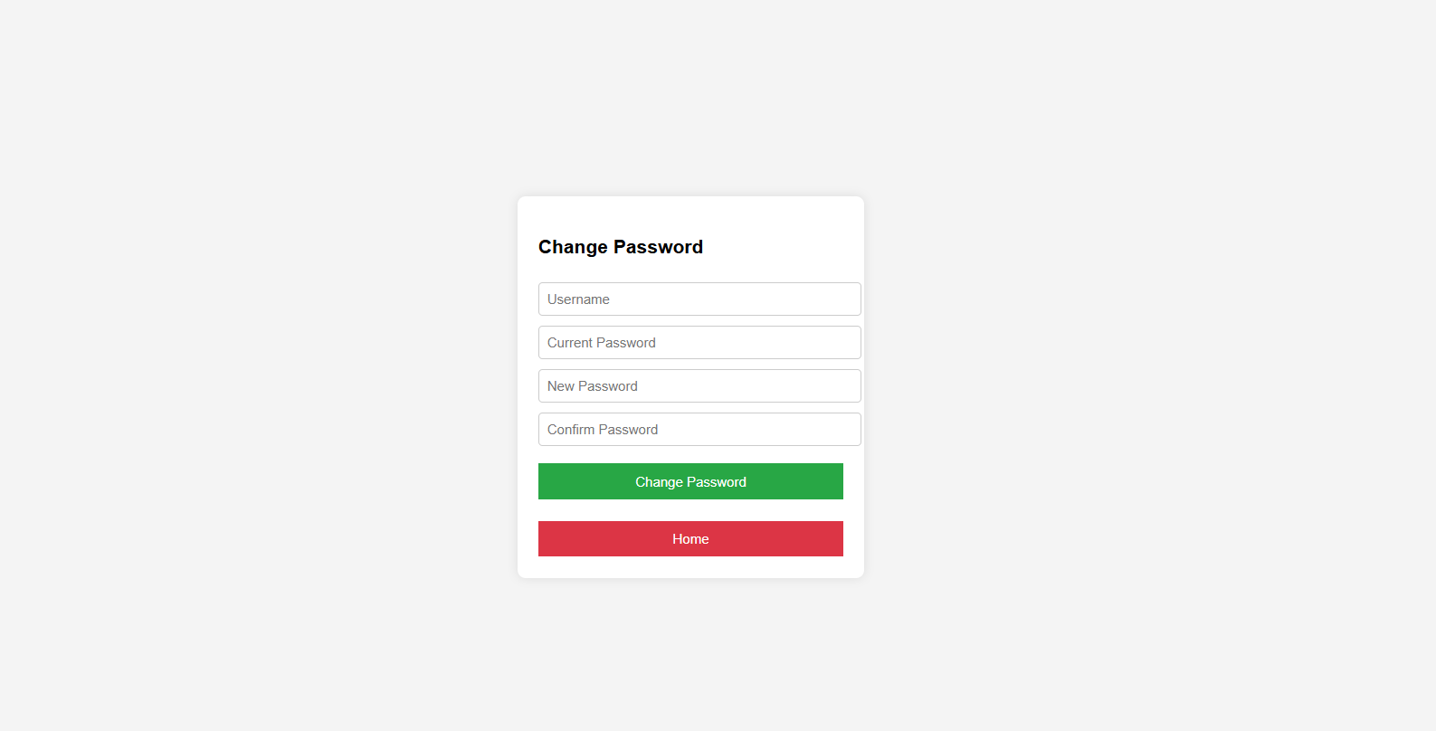
Figure 18 Change Password
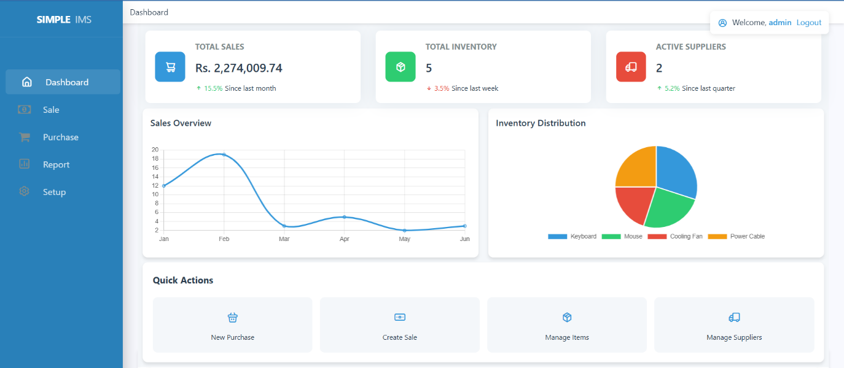
Figure 19 Dashboard page
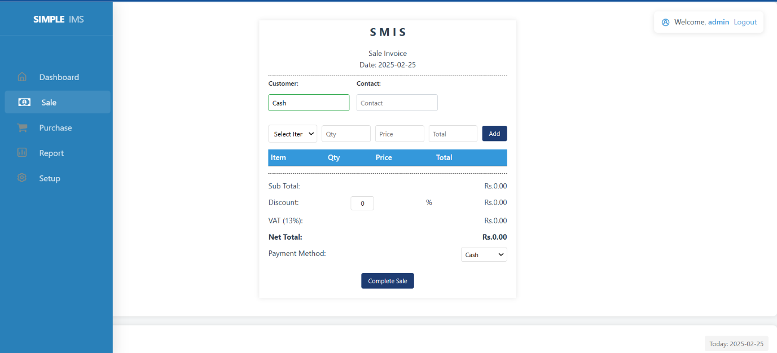
Figure 20 Sale page

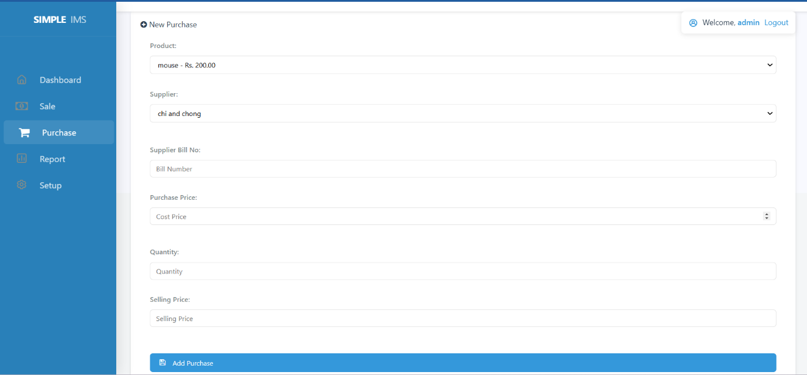
Figure 21 Purchase page
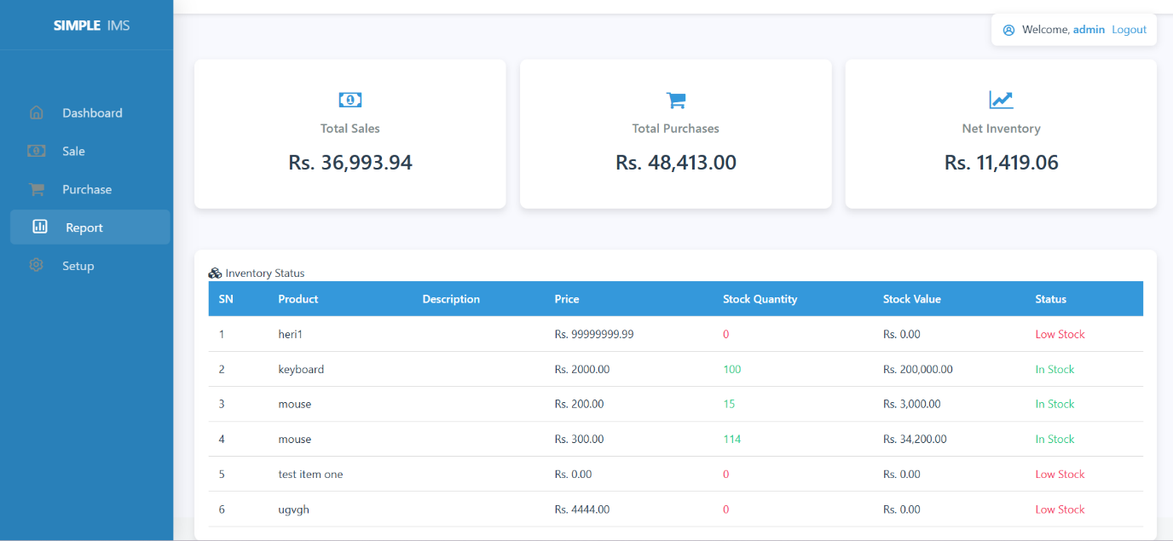
Figure 22 Report page
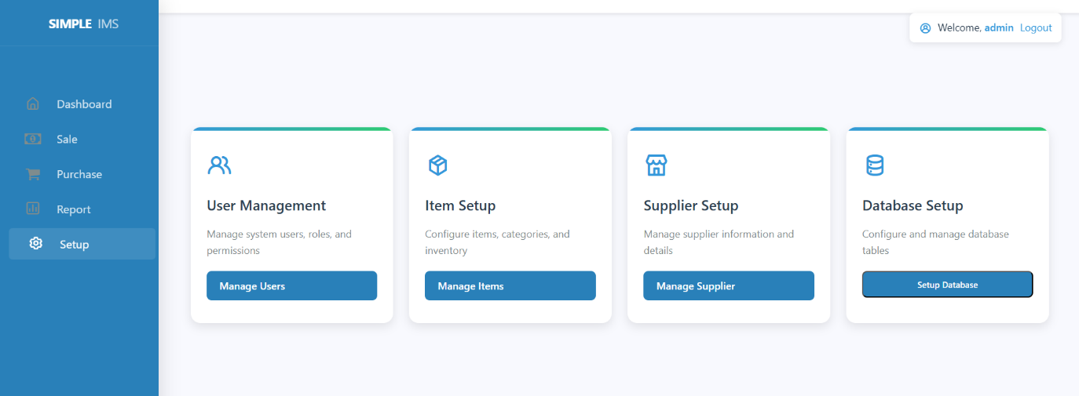
Figure 23 Setup page

Log book sheet entry
Meeting No: 01 Date: 2024/12/27
Start Time: 9:00 am Finished Time: 11:00 am
Discussion Topics:
Basic concept discussion with the over view of projected title. The explanation of the flow and architecture verbally.
Achievements:
Clear about the concept of the system but the planning should be carried out smoothly.
Problems (if any):

Task for Next Meeting:
Planning for the design and concepts

Student Name: Bibek Bhandari Supervisor: Deepak Thakur
Signature: Signature:

Log book sheet entry
Meeting No: 02 Date: 2024/01/11
Start Time: 9:00 am Finished Time: 11:00 am
Discussion Topics:
Planning for the design and concepts

Achievements:
The system requirement with the tools to use are discussed along with the references for the design are also noted along with the documentation.
Problems (if any):

Task for Next Meeting:
Database design and UI interface discussion.

Student Name: Bibek Bhandari Supervisor: Deepak Thakur
Signature: Signature:

Log book sheet entry
Meeting No: 03 Date: 2024/01/21
Start Time: 9:00 am Finished Time: 11:00 am
Discussion Topics:
Design of the database and the UI of the system.
Achievements:
The DBMS application and the tools of the design of the UI and database are discussed and meeting was very helpful for the further processing of the project.
Problems (if any):
The basic DBMS is need for the handling of the web application and the basic UI needed with the basic required in every day activity.
Task for Next Meeting:
Development if web application

Student Name: Bibek Bhandari Supervisor: Deepak Thakur
Signature: Signature:

Log book sheet entry
Meeting No: 04 Date: 2024/02/09
Start Time: 9:00 am Finished Time: 11:00 am
Discussion Topics:
Development of the web application was very challenging for the logical connect and handling of the data throughout the template and designed are also adjusted due to complication.
Achievements:
The using of tools and documentation is very helpful during this meeting. The logical part the debugging in the code was achieved.
Problems (if any):

Task for Next Meeting:
Testing of the system

Student Name: Bibek Bhandari Supervisor: Deepak Thakur
Signature: Signature:

Log book sheet entry
Meeting No: 05 Date: 2024/02/15
Start Time: 9:00 am Finished Time: 11:00 am
Discussion Topics:
Testing of the system is the current topic for the discussion and the meeting was scheduled for the more two days long
Achievements:
Minor bugs were removed and problems in the concept and logical part is also corrected. The failure during the different action was also corrected.
Problems (if any):
This sale and purchase are not working correctly. The dashboard designed should be improved and the color combination should be managed
Task for Next Meeting:

Student Name: Bibek Bhandari Supervisor: Deepak Thakur
Signature: Signature:

